Just Don’t App

# Group Banner IDs:

* B00312114
* B00330156
* B00283188

Description:

* Whenever the user wants to review an area he/she just needs to select it and (selecting the area inside a rectangle) will be given reviews/user comments on the area.
* Multiple reviews will determine the general opinion of the selected area and a message will be sent to the use. (Pleasant, unpleasant, dangerous).
* Users can choose how they will receive notifications for different messages. For example: The user could choose to be notified by vibration notifications when approaching nice areas, and sound notifications when approaching unpleasant/dangerous areas to make sure they are more likely to be aware.
* Users will be able to read other people’s reviews/comments on areas as well as see when how recent these reviews are, giving them a better idea on how accurate the general opinion of the area is.
* Users will also have the ability to add their own reviews and comments, simply by selecting the area, as they do when looking for reviews, then click the “add review button.”

Requirements:

* Mobile Device – Android/iOS with vibration/sound notifications, touchscreen, geo-locator, internet access and amplifier.
* Geo-locator turned on.
* User Community Based, requires time and user activity to input areas.

# Prototype Example Images

* Detailed look at the map that will be displayed in the application.

Icons selectin Areas

Coordinates

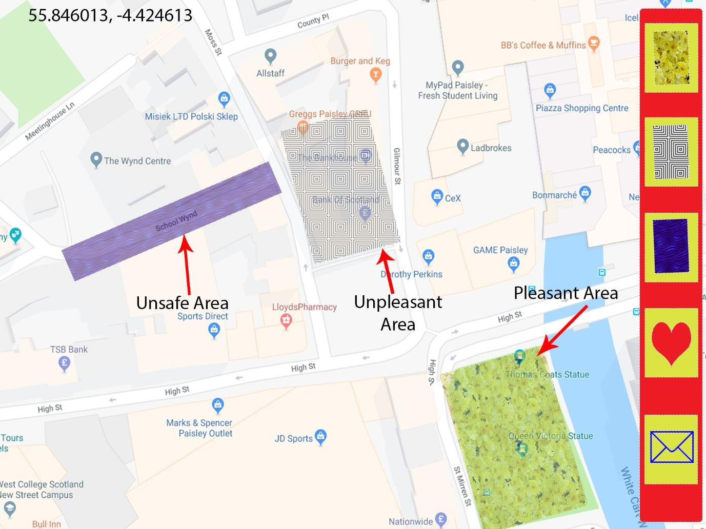

* An early version of the app screen when it has been opened

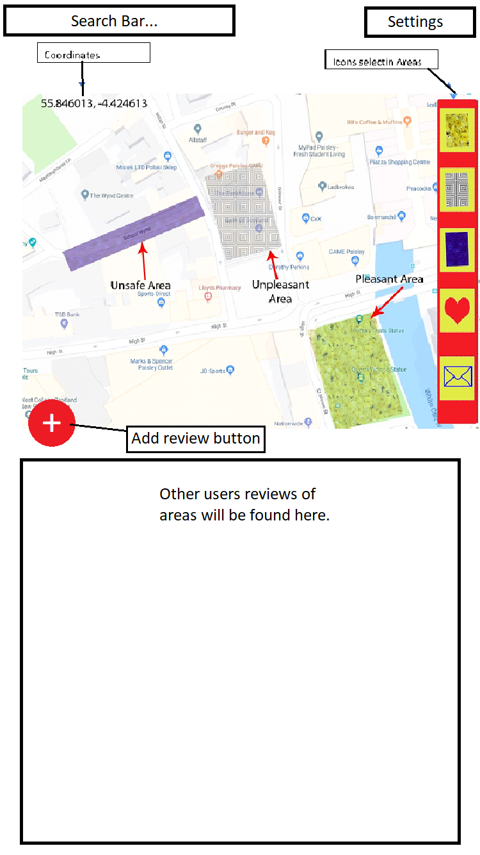

* What the user will see when adding a review. Ideally the content behind the review box would grey out slightly or decrease in opacity.

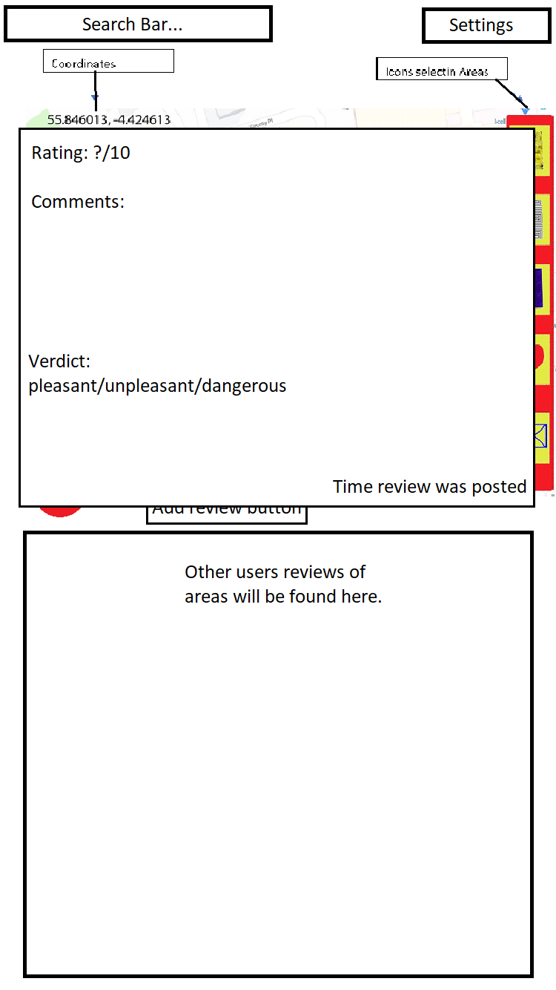

# Use Case Diagrams

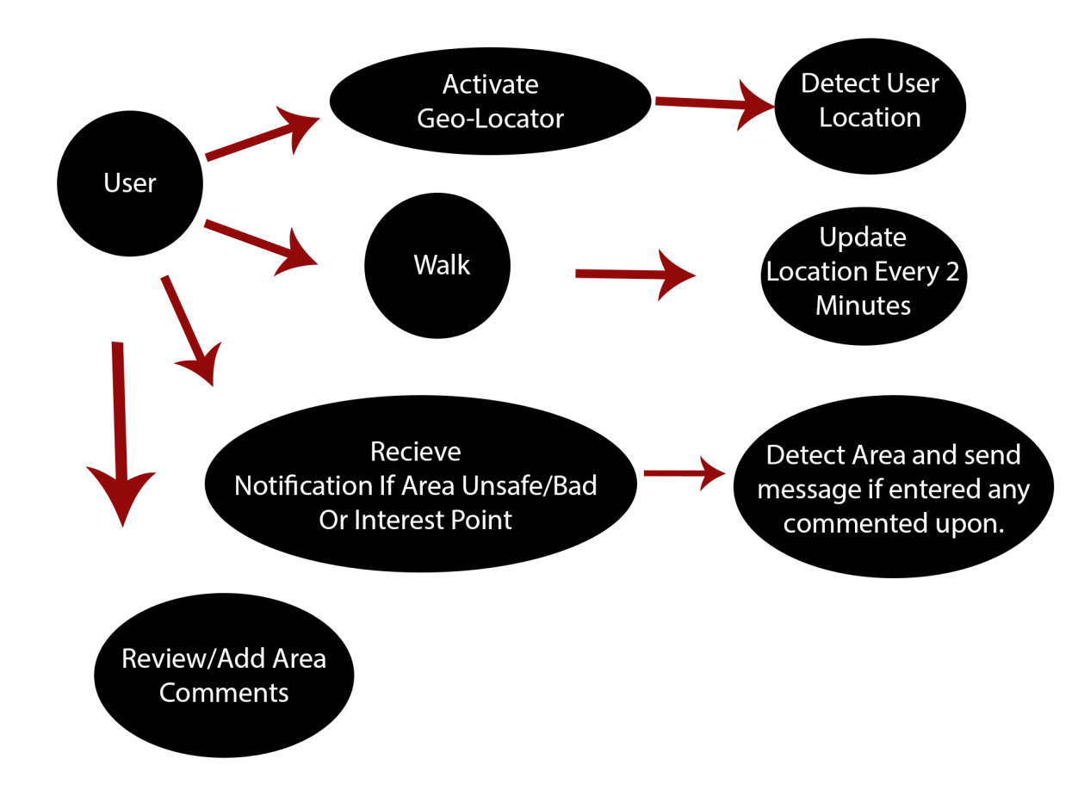

Time

# Use Case Descriptions

## User Activates Geo Locator

ID: Geo-locator Not Active

Actor: User

Precondition: Open app

Flow of events:

1. User opens app.
2. App determines if geo-locator is on (Ask to turn on if it’s not on).
3. App centres in location of user.

Post Condition: User location displayed.

## Create / Review

ID: Create + Review

Actor: User

Preconditions: Open app, location chosen, no other area created where user wants to add.

Flow of events:

1. User gets a square tool to select an area (drag and drop).
2. Select review (pleasant, unpleasant, or dangerous).
3. Click confirm.

Post Condition: Review appears on app to all users.

## Review Area

ID: Review

Actor: User

Precondition: Open app, area created by a user.

Flow of events:

1. User clicks on reviewable area.
2. Options appear (Pleasant, unpleasant, dangerous).
3. Select One.
4. Click confirm.

Review added to area, most votes on review decide which type of area it is.

## Update Location

ID: App update

Actor: Time

Precondition: App previously opened, running in background, geo-locator active.

Flow of Events:

1. Every 2 minutes update user location.
2. Check if inside of reviewed area.

Post condition: If inside an area send respective notification.

# Psuedocode

## Map Psuedocode

On mouse click  
{  
 Get location; // Gets longitude and latitude to determine location.  
  
 If (location is inside a reviewed area)  
 {  
 If (area has been reviewed)  
 {  
 Display previous reviews of area; // Displays list of reviews.  
 Prompt user to add another review; // Prompts user to add review.  
 }  
 Else  
 {  
 Prompt user to add the first review; // Prompts user to add review.  
   
 }  
   
 Display Add Review button;  
  
 If (Add Review button is clicked)

{

Add Review Modal appears; // Add Review Modal is displayed.  
 }  
 }  
}

## Home-page Buttons Psuedocode

If (mouse hover = true)  
{  
 Button changes colour to blue; // If mouse hovers over any button it turns blue.  
}  
Else   
{  
 Button colour is grey; // If mouse doesn’t hover on button it changes to grey.  
}

### Settings Button

On mouse click  
{  
 Settings Modal appears; // Displays Settings Modal over map.  
  
 If (screen size = or below average phone screen size)  
 {  
 A scroll bar is added to Modal; // Ensures all information is readable.  
 }  
}

### Account Button

On mouse click  
{  
 Account Modal appears; // Displays Account Modal over map.  
  
 If (screen size = or below average phone screen size)  
 {  
 A scroll bar is added to Modal; // Ensures all information is readable.  
 }  
}

### Add Review Button

On mouse click  
{  
 Add Review Modal appears; // Displays Add Review Modal.  
  
 If (screen size = or below average phone screen size)  
 {  
 A scroll bar is added to Modal; // Ensures all information is readable  
 }  
}